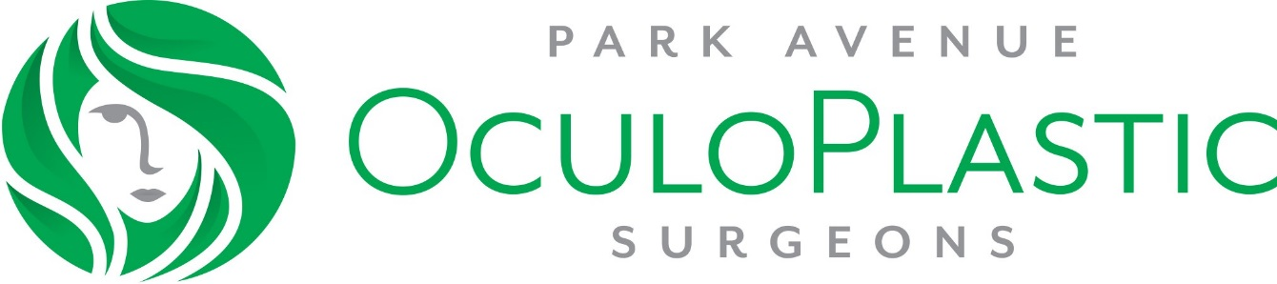
INFORMED CONSENT FOR EYELID LESION REMOVAL

WHAT CAN CAUSE THE NEED FOR EYELID LESION REMOVAL?
Some patients can develop a lesion or growth on their eyelid. It can sometimes represent a skin cancer but not always. Sometimes the lesion can irritate the eye. Other times the patient can be bothered by its appearance.

WHAT IS An EYELID LESION REMOVAL SURGERY?
This is a procedure to remove the lesion or growth from the eyelid.

HOW WILL EYELID SURGERY AFFECT MY VISION OR APPEARANCE?
The results of eyelid tightening depend upon each patient’s symptoms, unique anatomy. It also depends on how the tissue heals. The eyelid lesion is usually cut out and sometimes a stitch is placed to close the skin. It is difficult to assess whether stitches will be needed before the surgery in certain cases.

Removing an eyelid lesion will create a small scar. Some patients may have difficulty adjusting to changes to their appearance. Carefully evaluate your goals and your ability to deal with changes to your appearance before agreeing to this surgery.

WHAT ARE THE MAJOR RISKS?
Risks of eyelid lesion removal include but are not limited to: bleeding, infection, an asymmetric or unbalanced appearance, scarring, difficulty closing the eyes (which may cause damage to the underlying corneal surface), double vision, tearing or dry eye problems, inability to wear contact lenses, numbness and/or tingling near the eye or on the face, and, in rare cases, loss of vision. You may need additional treatment or surgery to treat these complications; the cost of the additional treatment or surgery is NOT included in the fee for this surgery. Due to individual differences in anatomy, response to surgery, and wound healing, no guarantees can be made as to your final result. For some patients, changes in appearance may lead to anger, anxiety, depression, or other emotional reactions.

WHAT ARE THE ALTERNATIVES?
It is possible to do nothing and live with the lesion. Some lesions are removed with freezing or with creams or ointments.

WHAT TYPE OF ANESTHESIA IS USED? WHAT ARE THE MAJOR RISKS?
Most eyelid lesion removal surgeries are done with “local” anesthesia, that is, injections around the eye to numb the area. You may also receive sedation from a needle placed into a vein in your arm or pills taken before surgery. Risks of anesthesia include but are not limited to damage to the eye and surrounding tissue and structures, loss of vision, breathing problems, and, in extremely rare circumstances, stroke or death.

PATIENT’S ACCEPTANCE OF RISKS
I have read the above information and have discussed it with my physician. I understand that it is impossible for the physician to inform me of every possible complication that may occur. My physician has told me that results cannot be guaranteed, that adjustments and more surgery may be necessary, and that there are additional costs associated with more treatment. By signing below, I agree that my physician has answered all of my questions, that I understand and accept the risks, benefits, and alternatives of eyelid lesion removal, and the costs associated with this surgery and future treatment, and that I feel I will be able to accept changes in my appearance .

_______________________________________ ________
Patient (or person authorized to sign for patient) Date

__________________________________________________________________________________________________________________________________

T/ 301-277-4844
F/ 301-927-3221

